Coding Challenges: PetPals, The Pet Adoption Platform

Implement OOPs Create SQL Schema from the pet and user class, use the class attributes for table column names.

1.Create and implement the mentioned class and the structure in your application.

• Name (string): The name of the pet.

• Age (int): The age of the pet.

• Breed (string): The breed of the pet. Methods:

• Constructor to initialize Name, Age, and Breed.

• Getters and setters for attributes. • ToString()

method to provide a string representation of the pet. Dog Class (Inherits from Pet): Additional Attributes:

• DogBreed (string): The specific breed of the dog. Additional Methods:

• Constructor to initialize DogBreed.

• Getters and setters for DogBreed. Cat Class (Inherits from Pet): Additional Attributes:

• CatColor (string): The color of the cat. Additional Methods:

• Constructor to initialize CatColor.

• Getters and setters for CatColor. 3.PetShelter Class: Attributes:

• availablePets (List of Pet): A list to store available pets for adoption.

Methods:

• AddPet(Pet pet): Adds a pet to the list of available pets.

• RemovePet(Pet pet): Removes a pet from the list of available pets.

• ListAvailablePets(): Lists all available pets in the shelter. 4.Donation Class (Abstract): Attributes:

• DonorName (string): The name of the donor.

• Amount (decimal): The donation amount. Methods:

• Constructor to initialize DonorName and Amount.

• Abstract method RecordDonation() to record the donation (to be implemented in derived classes). CashDonation Class (Derived from Donation): Additional Attributes:

• DonationDate (DateTime): The date of the cash donation. Additional Methods:

• Constructor to initialize DonationDate.

• Implementation of RecordDonation() to record a cash donation. ItemDonation Class (Derived from Donation): Additional Attributes:

• ItemType (string): The type of item donated (e.g., food, toys). Additional Methods:

• Constructor to initialize ItemType.

• Implementation of RecordDonation() to record an item donation. 5.IAdoptable Interface/Abstract Class: Methods:

• Adopt(): An abstract method to handle the adoption process. AdoptionEvent Class: Attributes:

• Participants (List of IAdoptable): A list of participants (shelters and adopters) in the adoption event. Methods:

• HostEvent(): Hosts the adoption event.

• RegisterParticipant(IAdoptable participant): Registers a participant for the event.

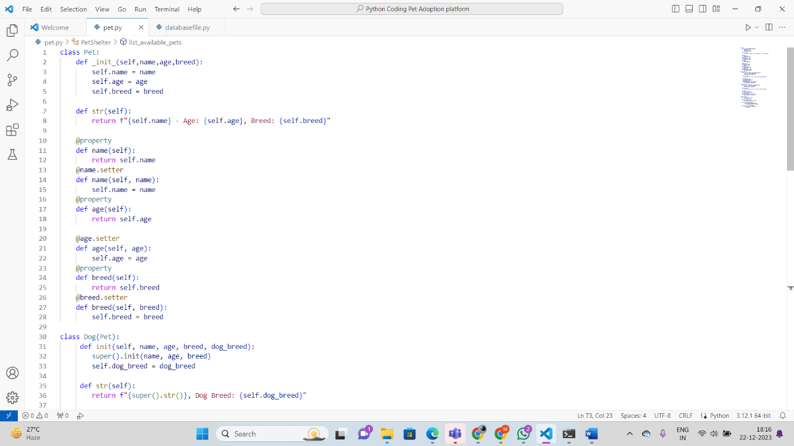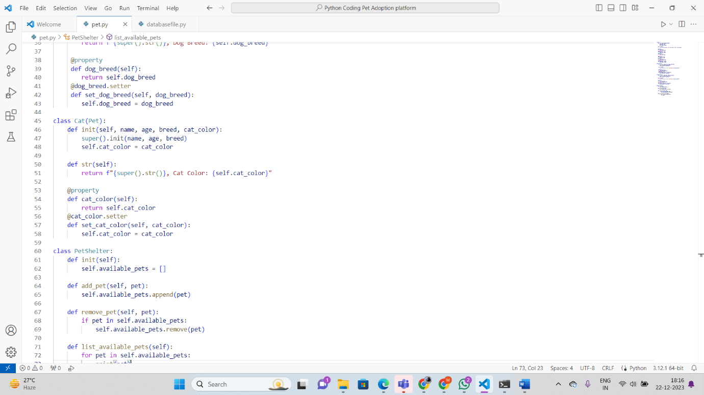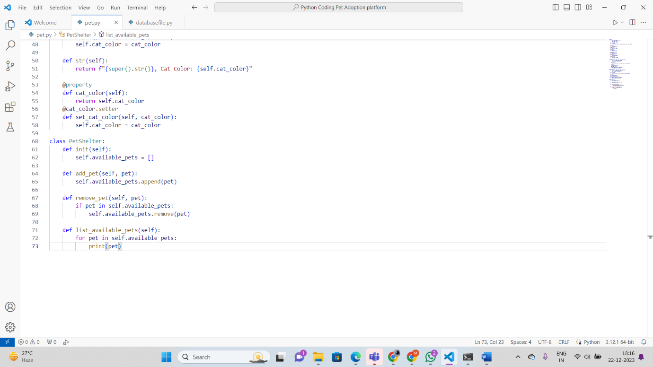

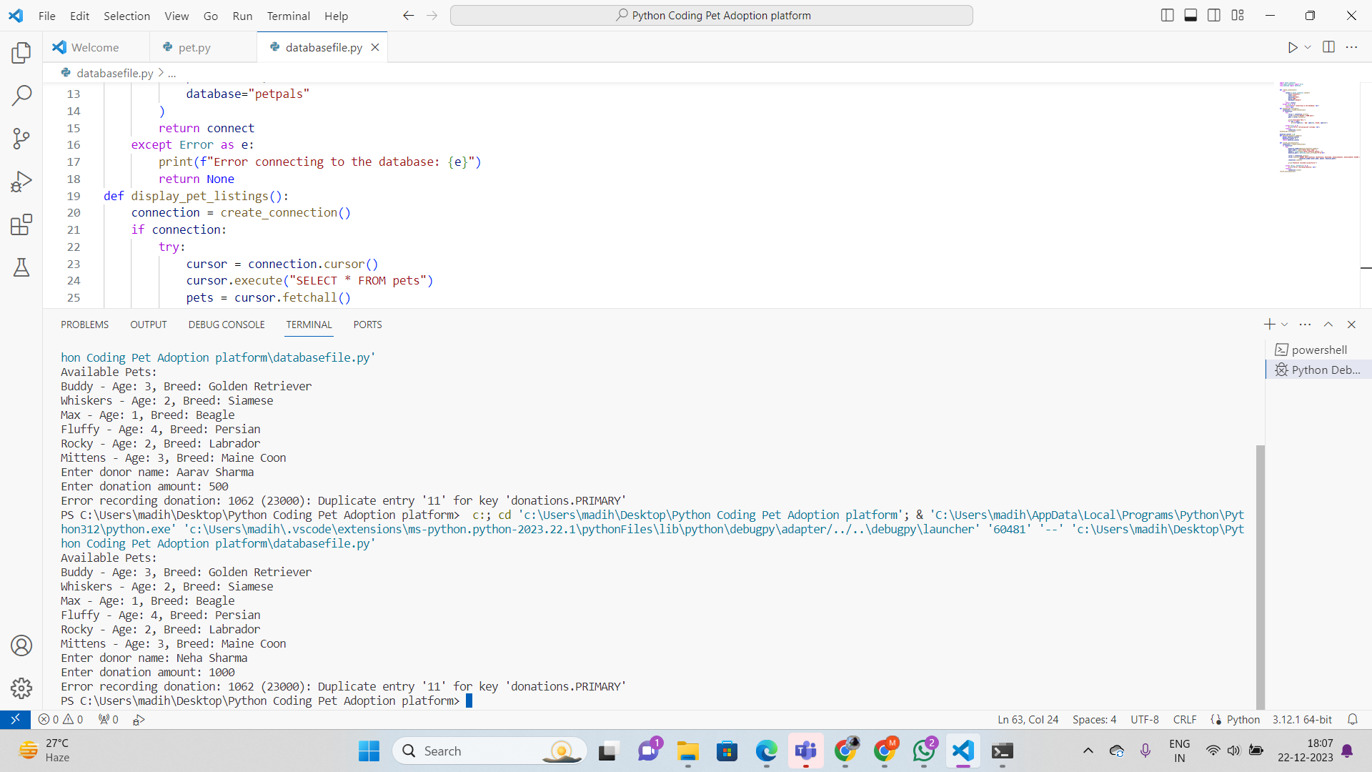

6.**Exceptions handling** Create and implement the following exceptions in your application.

• Invalid Pet Age Handling: o In the Pet Adoption Platform, when adding a new pet to a shelter, the age of the pet should be a positive integer. Write a program that prompts the user to input the age of a pet. Implement exception handling to ensure that the input is a positive integer. If the input is not valid, catch the exception and display an error message. If the input is valid, add the pet to the shelter.

• Null Reference Exception Handling: o In the Pet Adoption Platform, when displaying the list of available pets in a shelter, it's important to handle situations where a pet's properties (e.g., Name, Age) might be null. Implement exception handling to catch null reference exceptions when accessing properties of pets in the shelter and display a message indicating that the information is missing.

• Insufficient Funds Exception: o Suppose the Pet Adoption Platform allows users to make cash donations to shelters. Write a program that prompts the user to enter the donation amount. Implement exception handling to catch situations where the donation amount is less than a minimum allowed amount (e.g., $10). If the donation amount is insufficient, catch the exception and display an error message. Otherwise, process the donation.

• File Handling Exception: o In the Pet Adoption Platform, there might be scenarios where the program needs to read data from a file (e.g., a list of pets in a shelter). Write a program that attempts to read data from a file. Implement exception handling to catch any file-related exceptions (e.g., FileNotFoundException) and display an error message if the file is not found or cannot be read.

• Custom Exception for Adoption Errors

